06.05.20 Y3 Writing

LI: To use conjunctions effectively

Lesson outcomes

- Review conjunctions
- Use conjunctions to join simple sentences together (making complex and compound sentences)

Email completed work and any questions to: yr3@grange.harrow.sch.uk.

Task
Everyone must complete exercise 1.
Exercise 2 is an optional CHALLENGE for anyone brave enough to try it...

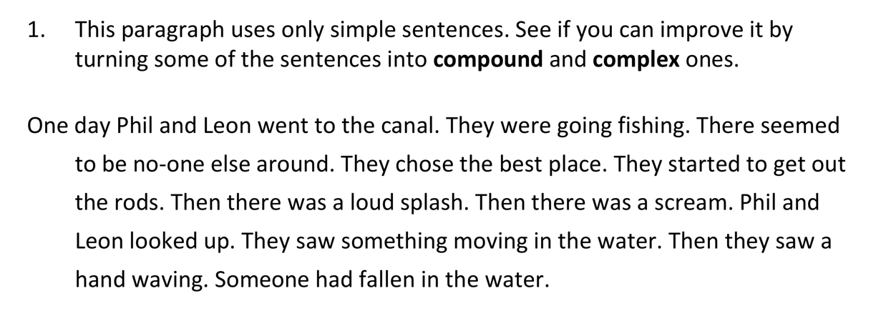

E.g. One day Phil and Leon went to the canal, since they were going fishing. There seemed to be no-one else around and they chose the best place.

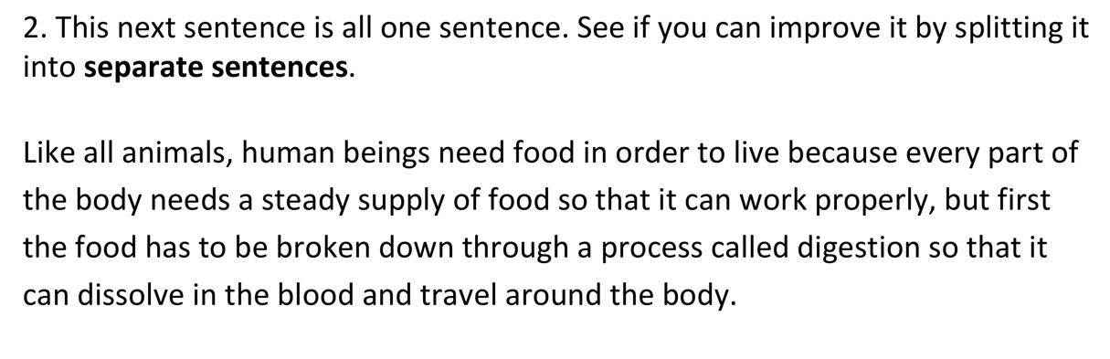
E.g. Like all animals, human beings need food in order to live. Every part of the body needs a steady supply of food so that it can work properly.

