Science Tasks 27th April 2020

Task 1

Name as many different vegetables as you can?

Name as many different plants you can?

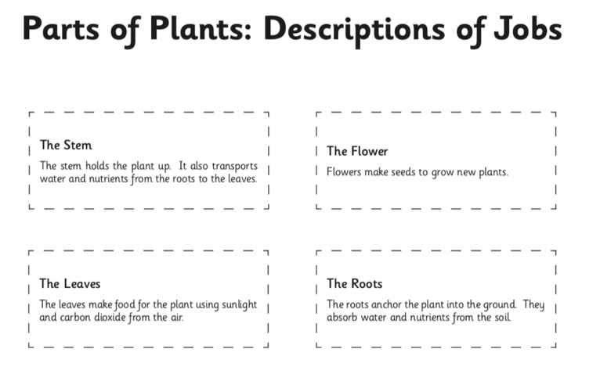

Select the 2 Star or 3 Star

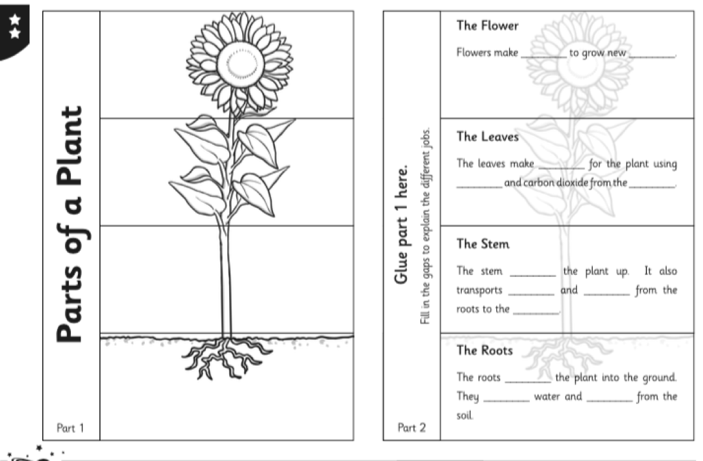

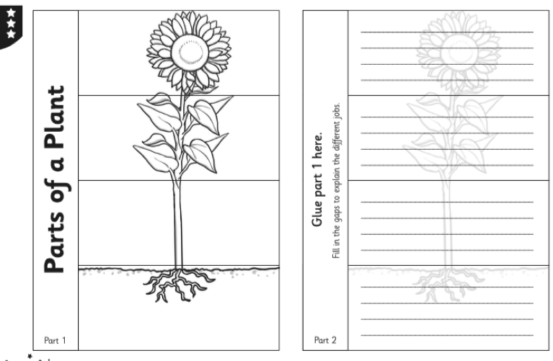

Task 2

What do plants provide us with to breathe?

What else do they provide us with?

How are plants different from each other?

What do most plants grow from?

What would sunflower seeds need, to grow into a healthy plant?

W………. A………. L……….. T………. T….. (WALTT)

Task 3

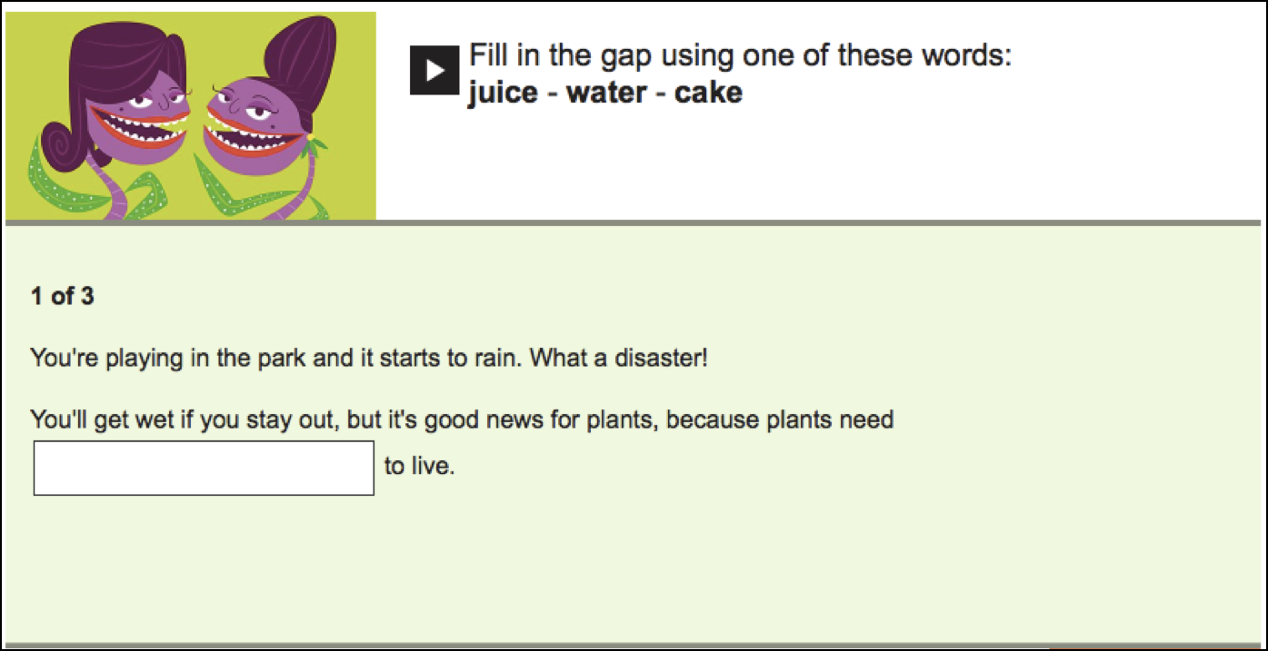

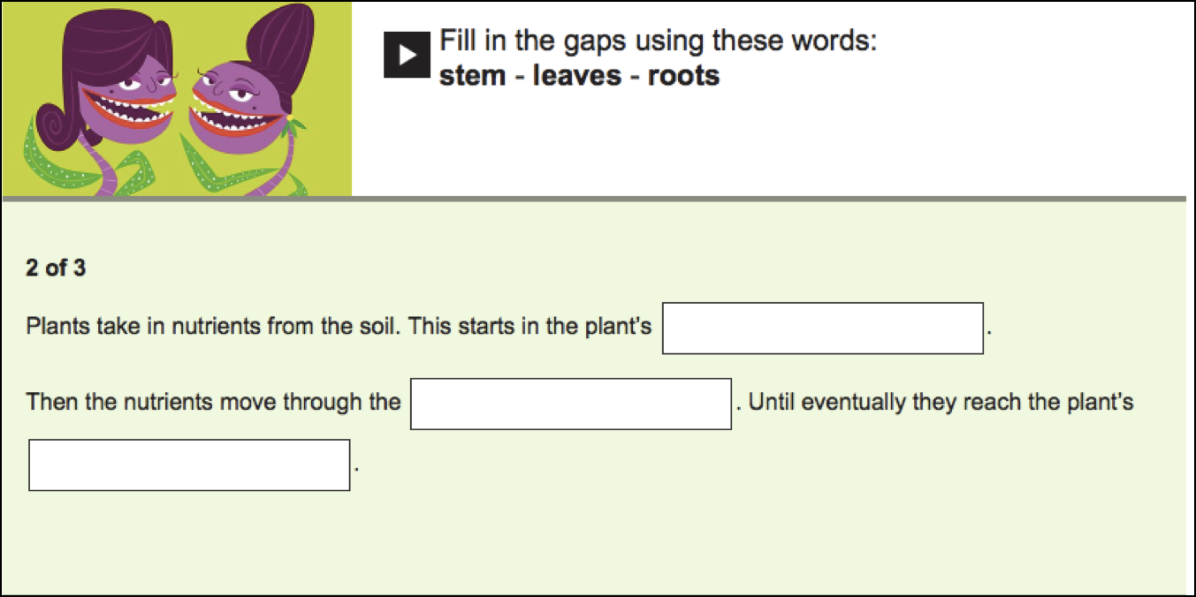

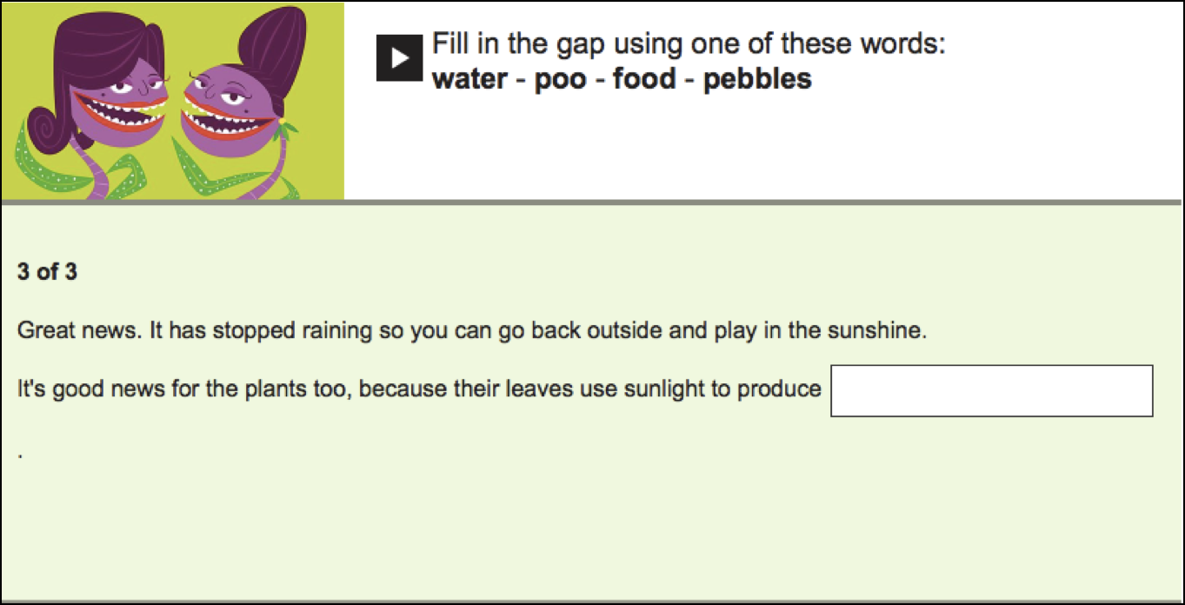

Task 4

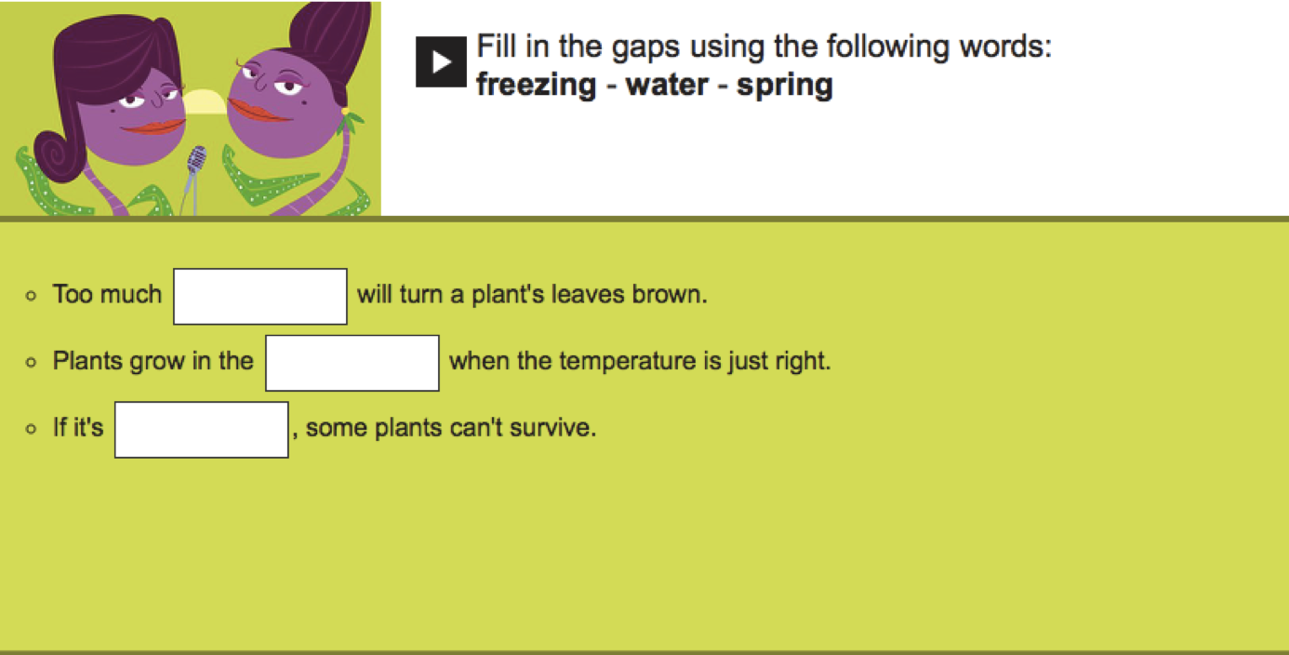

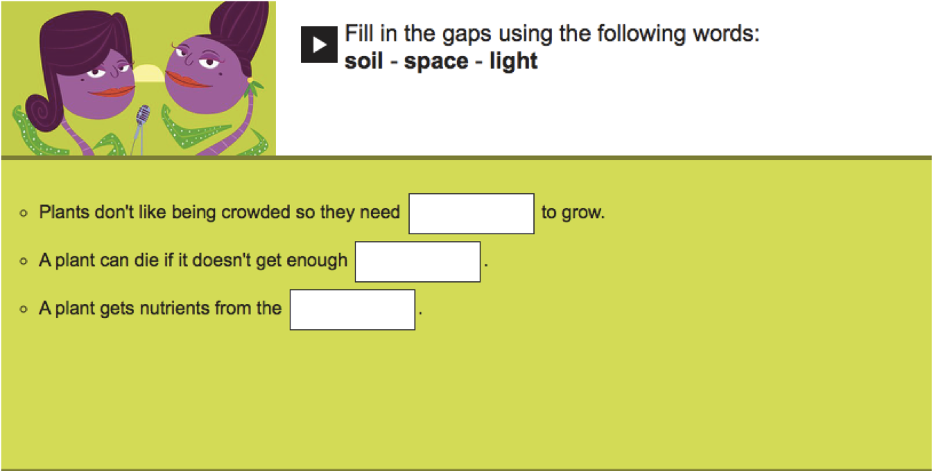

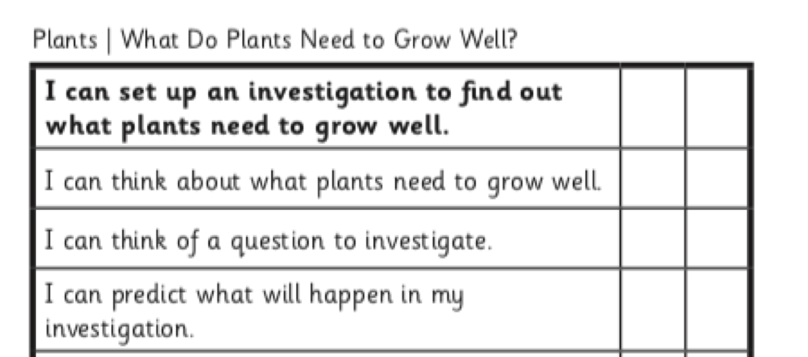
Select task you would like to do. (1*, 2* or 3*)

