

Knowledge Organiser
Year Group | Subject | Topic
4 | Geography | Can we make living better for everyone?
The Big Picture
This unit will develop an understanding of physical and human features that make up a place, town, city or area. Pupils will gain knowledge about settlements and how humans can influence the development of an area, such as roads, railway networks, commercial, industrial, shopping and housing developments
Students will find out about other cities and areas in the U.K and use maps, co-ordinates, grid references and eight points of the compass to build their knowledge of the U.K.
Pupils will also have opportunities to use fieldwork to observe, measure, record and present the human and physical features in the local area using a range of methods, including sketch maps, plans, graphs and digital technologies.

Enquiry questions
What are physical and human features? How do they affect were someone lives?
Why are compass directions useful?
What is an Ordinance Survey map? What is the best way to locate a place or symbol on a map?
Why is the street view on google earth a good feature to use?
How would you investigate traffic volume? Which graphs could be used to represent the data recorded?
Why do smaller areas in the UK have different name in each country? (county, council areas, principal areas and district)

Key Vocabulary
Physical and human features, towns/cities, compass directions, grid references, Google Earth, map, investigate, record, data, graphs, locate, identify, commercial. Industrial, residential, roads, railways, underground

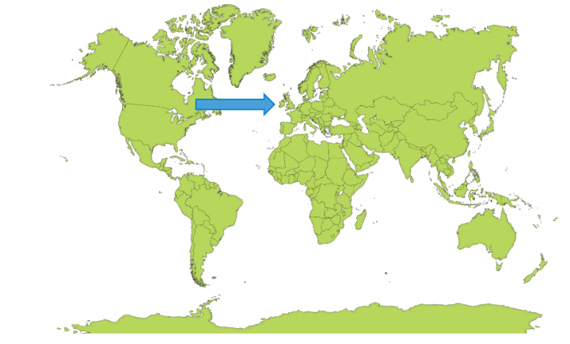 | 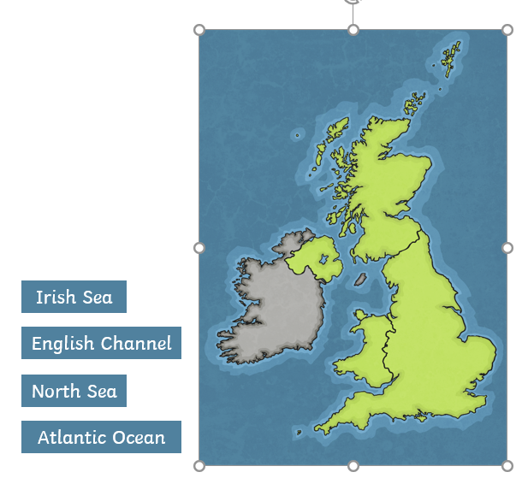
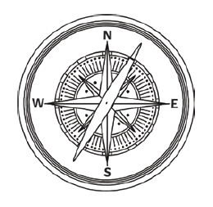 | 