
Knowledge Organiser
Year Group | Subject | Topic
4 | English | Old Possum’s Book Of Practical Cats by T.S. Eliot
The Big Picture
This half term we will be focusing on Old possum’s Book of Practical Cats by T.S Eliot. T.S Eliot’s playful cat poems have delighted readers and cat lovers around the world ever since they were first published in 1939. The book has appeared in several editions since 1939 and formed the basis for the musical ‘Cats’. The rich illustrations work well with the text to support the reader.
Children will be focusing on two purposes for their writing inspired by the core text; Writing to entertain where children write an adventure story from a cats point of view. The main focus of this stage is to write an adventure story with a wide range of adjectives and interesting vocabulary. Writing to persuade To write a persuasive leaflet on the topic
of ‘Cats vs. Dogs’. The main focus of this stage is writing persuasive text that has been improved through re-reading and editing.
Grammar Focuses
- Adjectives  - Adverbs  - Fronted adverbials  - Possession apostrophes  - Direct and indirect speech  - Prefixes and suffixes  - Pronouns  - Tenses: Past, Present and Future. | 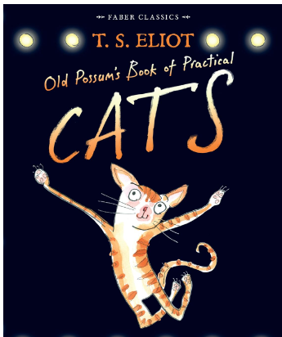

Grammar Definitions
Adjectives | An adjective is a word that describes or defines a noun or noun phrase.
Adverbs | An adverb is a word or an expression that generally modifies a verb, adjective, another adverb, determiner, clause, preposition, or sentence.
Fronted adverbials | Fronted adverbials are words or phrases placed at the beginning of a sentence which are used to describe the action that follows.
Possession apostrophes | A possessive apostrophe is a form of apostrophe that you use to show that something belongs to or is connected to something else. For example, Linda's bag
Direct and indirect speech. | Direct speech repeats the exact words the person used, or how we remember their words:  Barbara said, “I didn’t realise it was midnight.”  In indirect speech, the original speaker’s words are changed.  Barbara said she hadn’t realised it was midnight.
Prefix | A prefix is a letter or group of letters, for example 'un-' or 'multi-', which is added to the beginning of a word in order to form a different word. For example, the prefix 'un-' is added to ' happy' to form 'unhappy'.
Suffix | A suffix is a group of letters added to the end of a word to modify it, change its meaning and alter its grammatical function in a sentence. A suffix can change word class, tense, meaning or add extra information.  For example, in the word ‘happily’, the suffix ‘-ly’ changes ‘happy’ into an adverb that means ‘in a happy way’.
Tenses | A tense is a form of the verb that allows you to express time. The tense of the verb tells us when an event or something existed or when a person did something.

