
Knowledge Organiser
Year Group | Subject | Topic
4 | English | The Pebble in my Pocket: A History of Our Earth by Meredith Hooper
The Big Picture
This half term we will be focusing on The Pebble in my Pocket: A History of Our Earth by Meredith Hooper. The Pebble in my Pocket tells the life story of a pebble. Pebbles are likely to be familiar objects, but children may tend to ponder about where they come from. Adding features to a pebble is a way of leading into the idea of the life story of a pebble.
It covers difficult concepts using the familiar object of a pebble. Meredith Hooper uses metaphor to make the subject matter accessible while using terminology which will extend the children’s vocabulary. The use of movement verbs to describe all aspects of the journey of the pebble will lead into dance and poetry work. The rich illustrations work well with the text to support the reader.
Children will be focusing on two purposes for their writing inspired by the core text; writing to entertain where children write a poem focussing on varied vocabulary and performance. Writing to inform where children write a non-chronological report about dinosaurs 100 million years ago. The main focus of this stage is to research and take notes, use grammar in writing, organise ideas into paragraphs and understand the use of formal or informal language.
Grammar Focuses
- Formal and informal language  - Past tense  - Conjunction  - Research  - Paragraphs  - Grammar skils | 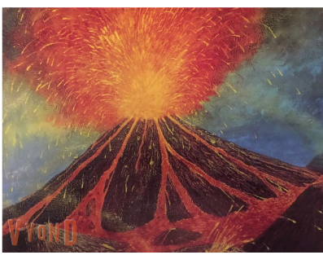

Grammar Definitions
Past tense | A tense expressing an action that has happened or a state that previously existed.
Formal language | It is used when writing for professional or academic purposes like graduate school assignments.
Informal language | It is more casual and used when communicating with friends or family either in writing or in conversation
Conjunction | A type of connective that joins clauses. Co-ordinating conjunctions include ‘and’,’ but’ and ‘so’. Subordinating conjunctions include ‘because’, ‘if’, ‘until’.
Research | The systematic investigation into and study of materials and sources in order to establish facts and reach new conclusions.
Grammar skills | The structure of a language or of languages in general, usually taken as consisting of syntax and morphology
Paragraph | A distinct section of a piece of writing, which usually has a single theme. It is indicated by starting a new line or indenting the start of the first sentence.

