
Knowledge Organiser
Year Group | Subject | Topic
4 | English | Azzi in between – Sarah Garland
The Big Picture
This half term we will be focusing on Azzi in between written by Sarah Garland. Azzi in between is a moving and a remarkable story that brings a little girl and her family to a brand-new country as refuges due to the constant wars taking place in her own country. The book illustrates a contrast between her life before she moved and now. The children will be focusing on two purposes for their writing inspired by the core text; writing to entertain where children write a diary entry from Azzi’s perspective at key points in the story focussing on extending sentences and maintaining clarity when writing from the perspective of a character. Writing to inform where children write an informative piece about the experience of refugees. The main focus of this stage is to arrange ideas into paragraphs around a topic and textual features of informative writing. We will be focusing on applying specific some grammatical features from the children’s prior learning in past year groups and other new features to ensure their ideas can be expressed in writing with clarity, creativity and confidence.
Grammar Focuses
- Past tense  - Pronouns  - Conjunction  - Fronted adverbial  - Paragraphs  - Direct speech | 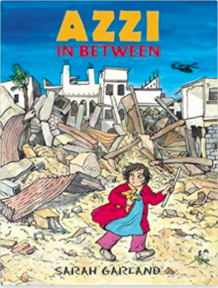

Grammar Definitions
Past tense | A tense expressing an action that has happened or a state that previously existed.
Pronouns | A word that can function as a noun phrase used by itself and that refers either to the participants in the discourse or to someone or something mentioned elsewhere in the discourse (I, you, he, she, it etc)
Conjunction | A type of connective that joins clauses. Co-ordinating conjunctions include ‘and’,’ but’ and ‘so’. Subordinating conjunctions include ‘because’, ‘if’, ‘until’.
Fronted adverbials | Words or phrases used at the beginning of a sentence, used like adverbs to describe the action that follows – for example: With a happy smile, she skipped into the room.
Direct speech | The reporting of speech by repeating the actual words of a speaker, for example ‘I'm going,’ she said.
Paragraph | A distinct section of a piece of writing, which usually has a single theme. It is indicated by starting a new line or indenting the start of the first sentence.

