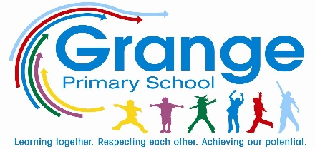
Knowledge Organiser
Year Group | Subject | Term | Topic
4 | English | Autumn 1 | Quest by Aaron Becker
The Big Picture
In Autumn 1, children in year 4 will be learning about narrative writing. First of all, what is narrative writing? It’s writing that tells a story. The basic elements that we will focus on are character, setting, and plot (problem & solution). Studying the structure of a narrative and discussing terms like rising action, climax, falling action, and a resolution. At this age we’re focused on does their writing make sense? And – are all the necessary elements there?
Picture Book - Quest
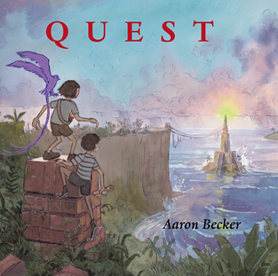
What is a Picture Book? A picture book is a book, typically for children, in which the illustrations are as important as—or more important than the words in telling the story. In picture books, there are illustrations on every page or on one page of every pair of facing pages. Picture books that tell the story completely through illustrations, with no words at all or a very few embedded in the artwork.
Quest by Aaron Becker is full of adventure, mystery, danger, daring and gorgeous illustrations. As two young friends make their way through the park, they are met by a curious visitor. A king who passes along some magical items and a quest that he needs completed. Suddenly he is abducted and the two young heroes are off! Through magical lands their bravery and ingenuity are tested at every turn. The author, with the use of intricately pushes detailed pictures, pushes young imaginations to the edge, while leaving the reader breathless with beautiful landscapes and heroic daring. From page to page the fantastic lands fill every page with colour. The sketchy drawing style of the humans in the story do not in any way detract from the glory of their surroundings and story.

Key Vocabulary
Quest | A long search for something.
Character | A person in a play, story or film.
Setting | The place or type of surroundings where an event takes place.
Imagination | The ability of the mind to be creative or resourceful.
Event | A thing that happens or takes place, especially one of importance.
Predict | To say what you think will happen in the future or will be a consequence of something.
Dilemma | A difficult situation or problem.
Resolution | The action of solving a problem

How do I read a wordless text?
- Before you begin, keep this one thing in mind: you’re not about to tell your audience a story. You’re about to discover one — together. And if all goes well, they’ll be telling one to you!
- Ask your child about the title. What do they think it means? What do they think the story might be about based on the cover alone? Ask for evidence.
- As the story begins, you can start with this basic question: what do you see? Get your child hunting for clues.
- As the story progresses, you can start asking other types of questions, such as: “How do you think [a character] is feeling?” “How do you know?” “Do you ever feel this way?”
- At moments of tension or conflict, ask, “What would you do?” I think this help children identify with the characters’ challenges.
- Sometimes you might want to take the reins for a while and narrate the story, especially if your child seems unfocused. It’s a balancing act. Remember, not only are the children engaging with the story, but you are, too!
- Lastly, and this is something to keep in mind throughout the reading, remember to take your time. It’s easy to rush through the pages, but don’t! You’ll miss out on the most rewarding part of sharing a wordless book: allowing your child to discover a story of his or her very own.

