

**Knowledge Organiser**

|  |  |  |
| --- | --- | --- |
| **Year Group** | **Subject** | **Topic** |
| **2** | **English** | **Writing to Entertain & Inform** |

|  |
| --- |
| **The Big Picture** |
| In this unit we will be exploring “Baboon on the Moon a text by by Claire Bates. Using this text as stimuli, we will be developing core comprehension skills such as prediction and retrieval. Lessons will incorporate a mixture of drama and written work to ensure thorough understanding of the story and characters.  Grammar work will continue to reinforce students’ understanding of sentence structures and use of descriptive language for interest. This will extend to introducing consistent use of pronouns into written work and building upon students’ understanding of fragments and run-on sentences. This should aid them to avoid or correct common writing mistakes. Towards the end of the unit we will include final written pieces in children’s published workbooks.  Meanwhile, creative writing tasks will take inspiration from these texts to develop students’ descriptive and spelling and grammar rules. |
| **Enquiry Questions** |
| * Do I understand how the characters in a story are feeling and what they may be thinking? * How do I start a sentence? * What are the different sentence types? * How do expanded noun phrases improve the quality of my writing? |

|  |  |
| --- | --- |
| **Key Vocabulary** | |
| **Fragment** | An incomplete sentence: missing a subject or verb, an incomplete thought. |
| **Run-on sentence** | Too many sentences/ independent clauses improperly squashed into one. |
| **Expanded noun phrase** | An expanded noun phrase is a noun phrase where more detail or information is given about a noun through the addition of adjectives , and sometimes prepositional phrases. E.g. ‘the furry, black dog with a small tail’. |
| **Exclamation** | A sentence type that shows intense feelings or used to get attention, ending in an exclamation mark (!). |
| **Question** | A sentence type that we ask or write to gain further information from a person or people responding, ending in a question mark (?). |
| **Pronoun** | A pronoun is a word used to replace a noun. Examples of pronouns are: he, she, it, they. |
| **Prediction** | A statement that someone makes about what they think is going to happen. |

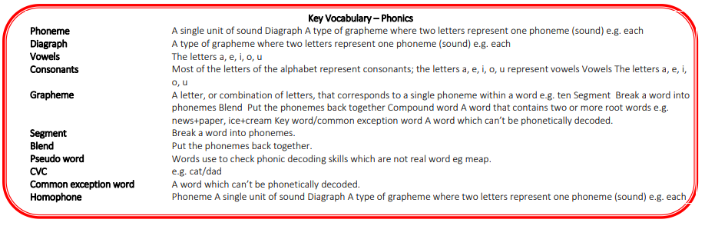

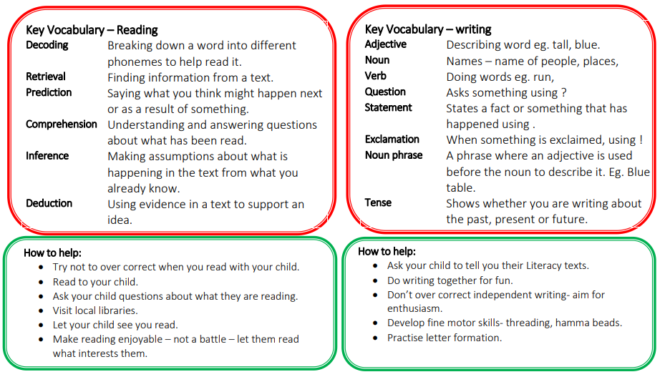

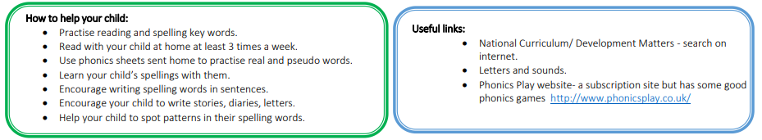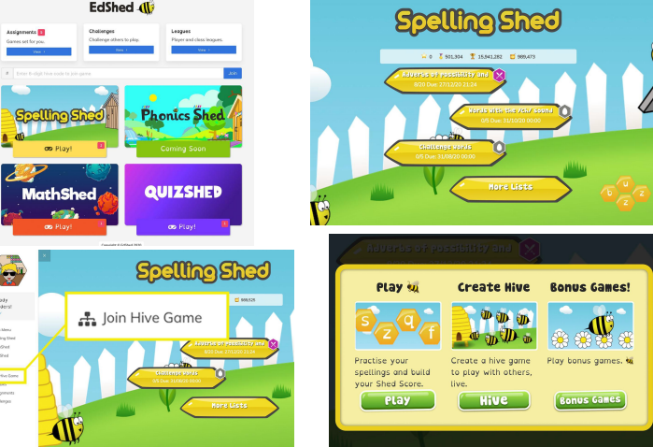

Remind children to login to Spelling Shed to access and learn their spellings each week.

<https://www.spellingshed.com/en-gb/>