18th September 2025

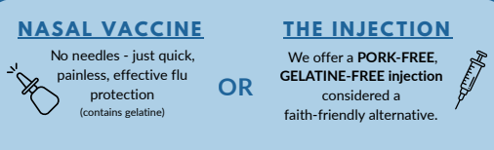

Dear Parents/Carers

**Re: Flu Vaccine for Reception, Years 1, 2, 3, 4, 5, and 6 Children**

We are writing to inform you that the flu vaccine will be administered at the school on **Wednesday 1st October 2025.**

This year the consent process is electronic. Please find below a link from NHS School Age Immunisation Team with details on how to complete the consent form online. Complete this form, even if you do not want the vaccine. https://nwl.schoolvaccination.uk/flu/2025/harrow

Please note the nasal vaccine contains gelatine derived from pigs. Flu vaccine will **only** be given to those children whose parents/carers have given their consent online.

**If your child becomes wheezy before or on the day of the vaccination session, please contact the school before 9.00am on Wednesday 1st October so the information can be passed to the School Nursing Team.**

Yours sincerely,

Mr D. Kerbel

Headteacher