Grange Explorers

Year 6 Adventure Book

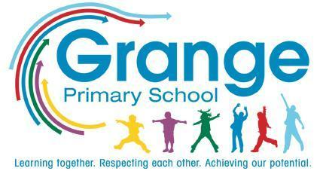
Name: ___________________________
Class: ___________________________
Collect a stamp for each task you complete!
Your Adventure Tasks

Task | Where? | Stamp
Design a home for the future | Home
Create your own Greek myth hero | Home
Visit an aquarium, sea life centre or museum with your family | Home
Make fruit batteries | School
Use a recipe book to plan a 2-course meal | Home
Buy items in a shop and check your change | Home
Visit a local charity shop and buy a piece of clothing to upcycle | Home
Learn how to access the news | Home
Code your own game | Home
Write, direct and edit your own play or short film | Home
Compose a rap or song | School
Create an orientation game using compass points | School
Draw a landscape of your local area | Home
Create a school newspaper | School
Carry out a weekly chore at home | Home
Write your own short book | Home
Create a map of landmarks in your local area | Home
Visit the Houses of Parliament or local council | Home
Teach a younger child a new skill | School
Write to your local MP about something important to you in your local area | Home
Find your way using a map | Home
Perform a weather forecast in Spanish | School
Create an activity to teach younger pupils Spanish | School
Research a Spanish or Latin American artist and create/re-create a piece of artwork in their style | Home
Join a game led by the Playground Buddies | School
Take part in Walk to School Week | Home/  School

