Grange Explorers

Year 5 Adventure Book

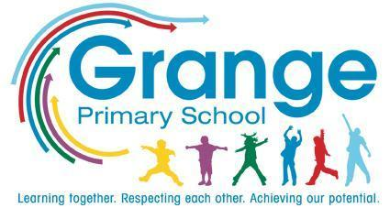
Name: ___________________________
Class: ___________________________
Collect a stamp for each task you complete!

Your Adventure Tasks

Task | Where? | Stamp
Learn how to play the violin | School
Visit a palace | Trip
Use an app to compose music | Home
Apply for a ‘job’ within the school | School
Write a picture book for a Reception child | Home
Make a model planet | Home
Read a story to a younger child | School
Visit a famous bridge | Home
Design and complete an obstacle course | School
Explore a World Heritage Site | Home
Put on a performance for your parents | School
Take part in a debate | School
Perform a Shakespeare play | School
Pick someone special a bunch of wildflowers | Home
Pick up litter in your local area | Home
Write a letter to a friend | Home
Draw a constellation map | Home
Design and build a Tudor house | Home
Visit a science or space centre | Trip
Plan a route and walk it with a family member | Home
Go stargazing - can you spot any planets? | Home
Watch a film in Spanish | Trip
Create a poster about a Spanish or Latin American festival | Home
Join a game led by the Playground Buddies | School
Take part in Walk to School Week | Home/  School

