Grange Explorers

Year 4 Adventure Book

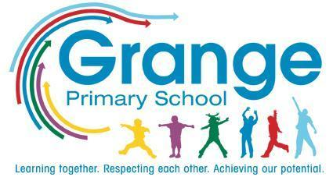
Name: ___________________________
Class: ___________________________

Collect a stamp for each task you complete!

Your Adventure Tasks

Task | Where? | Stamp
Perform a music concert | School
Visit a zoo | Home
Try a new food from a different culture | Home
Visit a park or nature reserve | Trip
Create a music video | Home
Choreograph a dance | School
Plan and cook a meal | Home
Take apart an electrical item to see how it works  (with permission!) | Home
Visit the Science Museum | Trip
Create your own documentary | Home
Learn about a religion and visit a place of worship | Trip
Create/do something to help the environment | Home
Create an animation | School
Create a model volcano | Home
Create art inspired by nature | Home
Read a ‘classic’ from children’s literature | Home
Learn a song in a new language | School
Learn to swim | School
Fly a kite (you could even make your own!) | Home
Translate your shopping list into Spanish | Home
Participate in a Spanish storytelling workshop | School
Join a game led by the Playground Buddies | School
Take part in Walk to School Week | Home/ School

