Grange Explorers

Year 3 Adventure Book

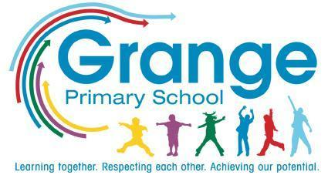
Name: ___________________________
Class: ___________________________
Collect a stamp for each task you complete!

Your Adventure Tasks
Task | Where? | Stamp
Write a diary entry as the Stone Age Boy | Home
Build a model of a Stone Age settlement | Home
Try cave painting using natural materials | School
Go on a nature hunt and collect items for a collage | Home
Visit the Natural History Museum | Trip
Make a fossil using salt dough | Home
Draw a map of your route to school | Home
Grow a plant and keep a photo diary | Home
Write a letter to your favourite author | Home
Design your own ancient Egyptian god | Home
Write your name in hieroglyphics | School
Visit the British Museum to see Egyptian artefacts | Trip
Read a traditional tale from another culture | Home
Create a mini-book retelling a myth or legend | Home
Choreograph a short dance with a friend | School
Make a musical instrument and perform a rhythm | Home
Try a new food from a different country | Home
Paint a landscape inspired by your local park | Home
Write and perform a weather forecast | School
Help an adult cook a healthy meal | Home
Pick up litter in your local area | Home
Create a gratitude jar with weekly entries | Home
Learn a poem by heart and perform it | Home
Play a team game and show great sportsmanship | School
Visit an art gallery | Trip
Record the sounds of nature and describe them | Home
Take part in a trust-building game | School
Draw a picture of yourself doing something brave | Home
Create an outdoor obstacle course | Home
Climb a huge hill | Home
Eat a picnic outdoors | Home
Design and create a Guatemalan worry doll | School
Create a factfile, “All About Spain” | Home
Join a game led by the Playground Buddies | School
Take part in Walk to School Week | Home/ School

