Grange Explorers

Year 2 Adventure Book

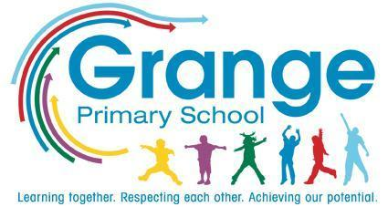
Name: ___________________________
Class: ___________________________
Collect a stamp for each task you complete!

Your Adventure Tasks

Task | Where? | Stamp
Make a birdfeeder | School
Play a game of rounders | School
Make a musical instrument | Home
Take photos of nature and create a collage | Home
Play a board game | Home
Complete a treasure hunt | School
Create a potion or ‘marvellous medicine’ | Home
Design and create a plasticine animal | Home
Toast marshmallows | Home
Sort foods we eat everyday or only sometimes (items or packaging) | School
Bake a cake | Home
Write your own song | Home
Keep a diary | Home
Make a hand puppet | Home
Visit your local library | Home
Make and wear a mask | Home
Draw a map of your bedroom | Home
Create a poster : How to care for your pet | Home
Learn and recite a poem | School
Interview a grandparent or older relative | Home
Go cloud watching | Home
Join a game led by the Playground Buddies | School
Take part in Walk to School Week | Home/ School

