Grange Explorers

Reception Adventure Book

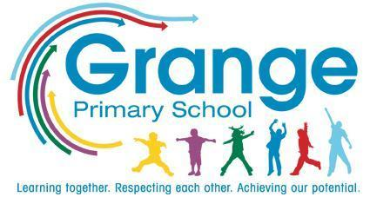
Name: ___________________________
Class: ___________________________
Collect a stamp for each task you complete!

Your Adventure Tasks

Task | Where? | Stamp
Go on a wellie walk and jump in muddy puddles | Home
Perform a dance to your favourite song | Home
Create a building using blocks, duplo or lego | School
Meet people who help us and ask them a question | School
Plant fruits or vegetables | School
Walk to the letterbox and post something | Home
Listen to a story from a different country | School
Visit the woods and climb a tree | Home
Make leaf rubbings | School
Make a boat out of recycled materials and see if it floats | Home
Visit your local library | Home
Play with ice | School
Follow a simple recipe | Home
Paint a self-portrait | School
Take a photograph | Home
Make a pirate’s treasure map | Home
Dress up as your favourite story character | Home
Listen to the noises of nocturnal animals | Trip
Have a teddy bears picnic | School
Help an adult with a job around the house | Home
Build a den | Home
Take part in Walk to School Week | Home/ School

